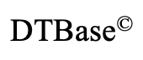**Design & Technology (Product Design)**

**A-Level**

**Materials required for questions**

* Pencil
* Rubber
* Calculator

**Instructions**

* Use black ink or ball-point pen
* Try answer all questions
* Use the space provided to answer questions
* Calculators can be used if necessary

**Advice**

* Marks for each question are in brackets
* Read each question fully
* Try to answer every question
* Don’t spend too much time on one question

**Time: 2 hours 30 minutes**

**Mark /120**

**Q1)** State what following acronyms stand for. **(3 marks)**

**PAR –**

**BSI –**

**HSE –**

**Q2)** The production of a car currently takes 15 people 80 hours to make a car. Each person is paid £9.21 per hour.

**Q2a)** Work out the total cost of making a car using people. **(2 marks)**

**Q2b)** The company hire an additional 15 people. State the effect on the time to manufacture the car and the cost to manufacture the car. **(4 marks)**

**Q2c)** The company then decide to replace all the workers with dedicated automated machinery. Evaluate the decision to do this discussing the effect on the workforce and manufacturer. **(6 marks)**

**Q3a) Blow moulding – 2 marks**

**Q3b) Diagram blow moulding – 4 marks**

**Q3c) Blow moulding – 6 marks**

**Q4)** The figure below shows a bench being used in a garden.

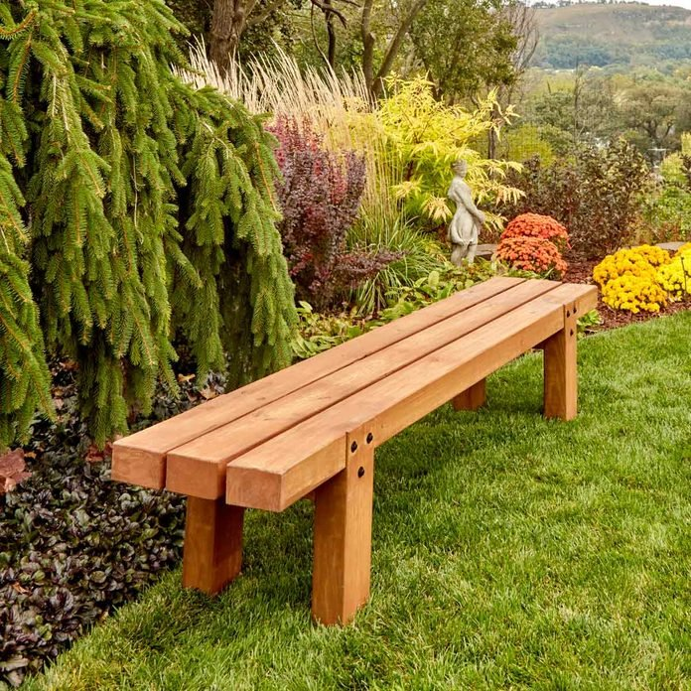

Explain two working properties of Oak that make it a suitable material to be used for the outdoor bench. **(6 marks)**

**Q5)** The figure below shows a section of track to be used in a new railway line.

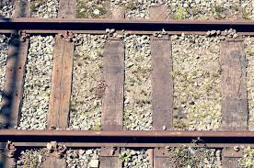

At the end of the sleeper’s usable lifespan, they are to be upcycled.

Explain 2 disadvantages of Upcycling. **(4 marks)**

**Q6a)** State the three forces being exhibited in this image below. **(3 marks)**

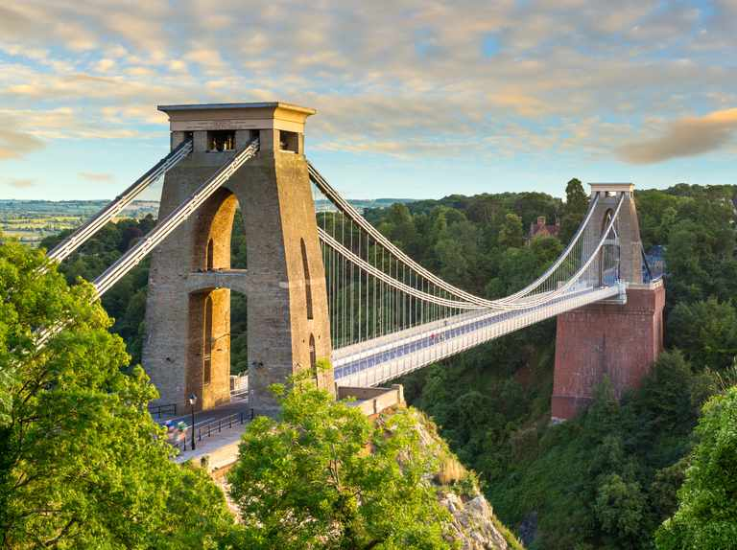

**Q6b)** A similar bridge is to be built abroad; the client wants a virtual model of the design. Explain two advantages of virtual modelling. **(4 marks)**

**Q6c)** The figure below shows a different bridge, this one is a laminated arch-bridge.

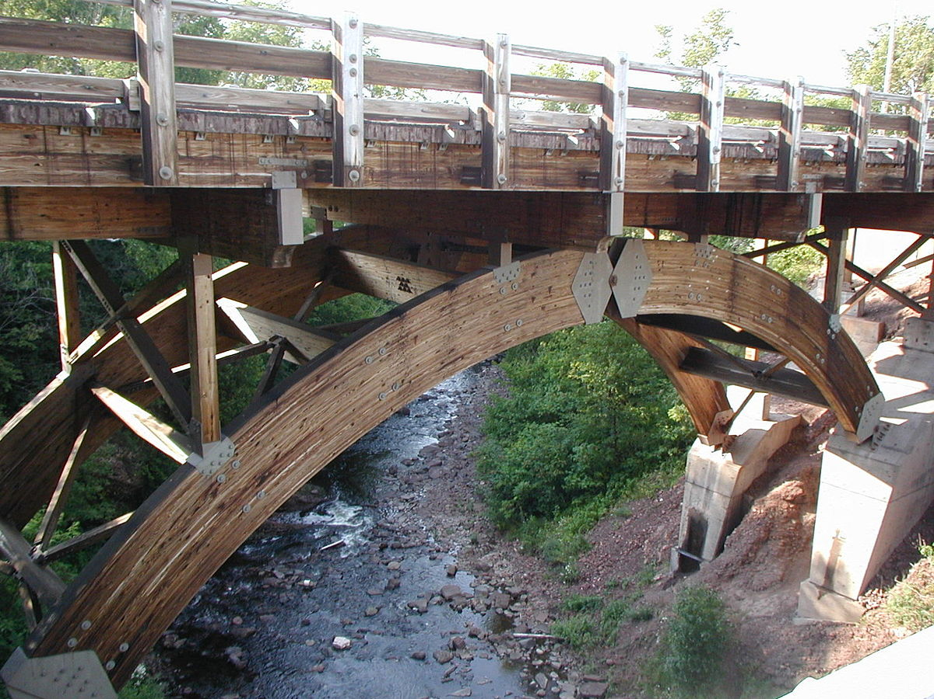

Describe the process of creating the laminated arches. **(6 marks)**

**Q6d)** The arch can be treated simply as a sector of a circle.

7m

Calculate the arch length in metres. **(4 marks)**

**Q7)** Explain one advantage of using knock-down fittings. **(2 marks)**

**Q8)** A DT student makes a critical path analysis to track the progression of his DT coursework. Give three features of critical path analysis. **(3 marks)**

**Q9)** Discuss the style and design philosophy of the Arts and Crafts movement. **(6 marks)**

**Q10)** Explain how rapid prototyping has affected on traditional manufacture. **(9 marks)**

**Q11)**

**Q12) Probability question. (3 marks)**

**Q13)** Explain two ways new and emerging technologies have impacted people. **(4 marks)**

**Q14)**

